Light and Spectra Pre-Lab
Student’s Name
Institutional Affiliation
Course
Professor’s Name
Date

Light and Spectra Pre-Lab
Q1. In common
There are three sorts of spectra to choose from. A continuous spectrum is an array of all wavelengths or colors of the rainbow (produced when a solid or highly dense gas emits radiation). A continuous spectrum can act as a background against which light can be absorbed by the atoms of a considerably less dense gas. A dark line, also known as an absorption spectrum, is a sequence or pattern of dark lines—missing colors—superimposed on a source's continuous spectrum. A bright line, also known as an emission spectrum, is a pattern or sequence of bright lines made up of light with just a few distinct wavelengths present.
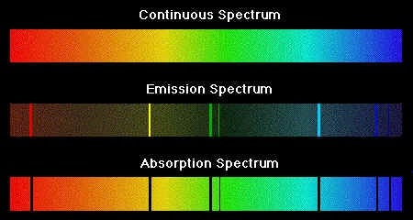
Q2
The atomic emission spectra of each element is distinct. You can tell which elements are present by looking at the spectrum. An atom's electrons leap to higher energy levels as it absorbs energy. They then leap to their feet and land. Each leap corresponds to a certain light wavelength.
Each atom has a large number of potential electron transitions. There is a distinct energy difference between each transition. An emission spectrum is a collection of transitions. These emission spectra are as unique to each element as a person's fingerprint is. As a result, scientists can identify the elements in atomic spectra.
Q3.
ν=c×Δλλ=(3.0×108m/s)(265nm5890nm)=(3.0×108m/s)(265×10-9m5890×10-9m)=450,000m/s=450km/s

Light and Spectra Lab Online.
Part 1. Spectra and Spectral Lines
- Element: Argon
Tube color: Violet
- Element: Carbon Dioxide
Tube color: Blue
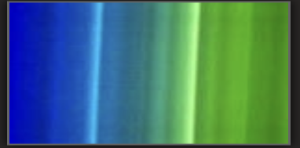
- Element: Krypton
Tube color: Gray
- Element: Mercury
Tube color: Blue
- Element: Neon
Tube color: Red
- Element: Water Vapor
Tube color: Blue

